**Test Document for Allow to put same price in Indent Line**

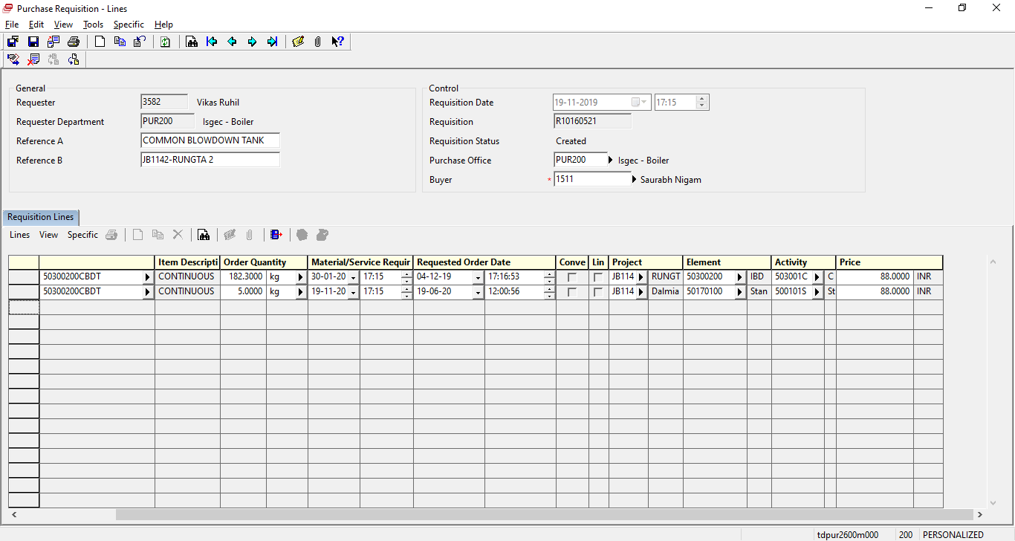

New line should be generate with different project and element with same item and same price